CIS31041 - Practical for Data Mining

Reg.No: SEU.IS.20.ICT.084 Lab Sheet 01

Question 01

The data set shown below the number of passengers flown by top five Airlines. Construct Bar Chart, Line Chart and Pie Chart to depict the following information.

Airlines | Delta | United | American | US Airways | Southwest
Passengers | 103,133 | 84,203 | 81,083 | 58,659 | 55,946

Construct Bar

Pie Chart

Line Chart

Year | Sales | Gross profit (Rs) | Net profit (Rs)
1974 | 100 | 30 | 10
1975 | 120 | 40 | 15
1976 | 140 | 45 | 35
1977 | 160 | 70 | 35
1978 | 170 | 75 | 40

Construct Bar Chart

Line Chart

Pie Chart

Question 02
Calculate Mean, Median, Mode, Quartiles, Inter Quartile Range (IQR)
- 36 , 48, 90, 67, 81, 41, 28, 34, 90, 77, 90

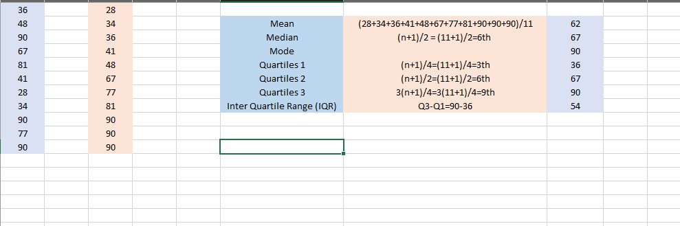

- 6 , 7 , 2 , 5 , 6 , 0 , 3 , 6, 7 , 4 , 5 , 4 , 5 , 7, 7

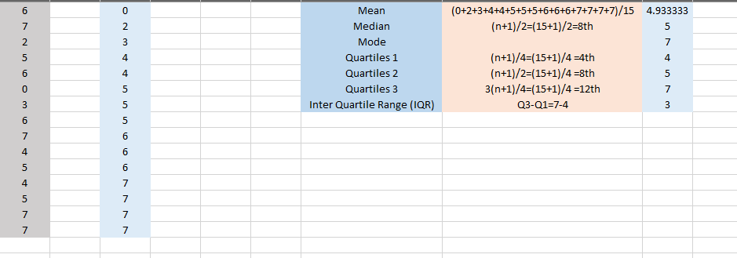

Question 03
- Estimate the following for the below grouped frequency distribution table
- Measures the mean, Var, Std, CV for the following data.

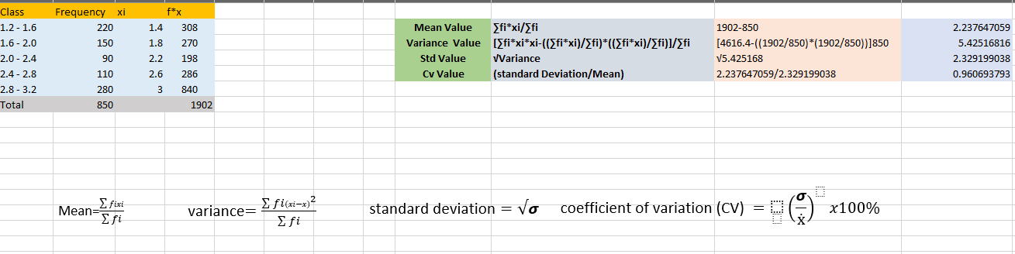
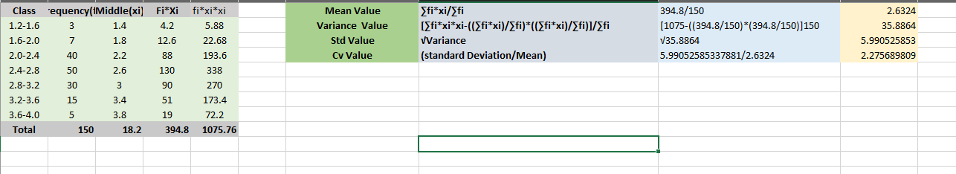

Question 04
Calculate the correlation coefficient of the following data set and find the linear regression model
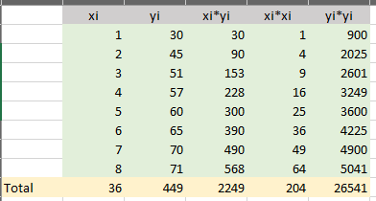
- (1,30), (2,45), (3,51), (4,57), (5,60), (6,65), (7,70), (8,71)

ii. (100,75), (120,90), (140,115), (160,140), (170,155)

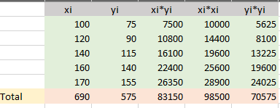

Exercises:
Construct Bar Chart, Line Chart and Pie Chart to depict the following information

Days | Number of Light |  | Power Bill
Day 1 | 10 | 100
Day 2 | 20 | 200
Day 3 | 30 | 300
Day 4 | 40 | 400
Day 5 | 50 | 500

Bar Chart

Line Chart

Pie Chart

Calculate Mean, Median, Mode, Quartiles, Inter Quartile Range (IQR)
- 8, 15, 18, 13, 15, 28, 30, 17, 41, 27, 17, 17, 44, 31, 24
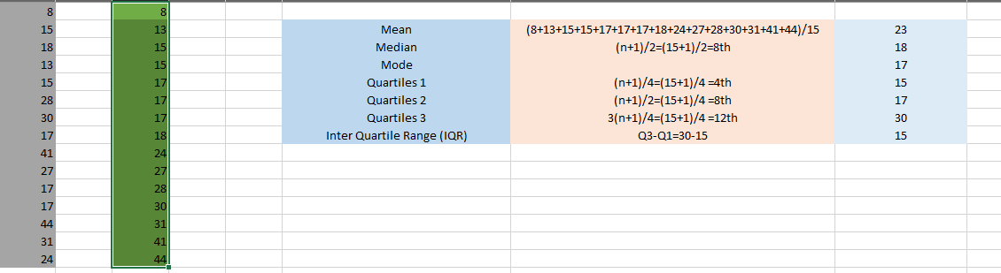

Calculate the correlation coefficient of the following data set and find the linear regression model

- (32,30), (36,30), (39,31), (40,39), (41,37), (41,34), (44,37), (45,41)

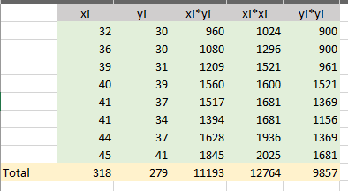

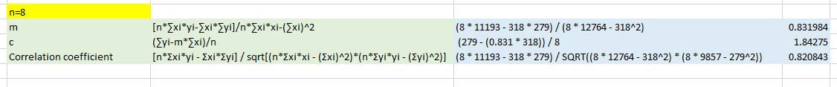

Discussion:

